**ANSWERS TO QUESTIONS FOR DISCUSSION AND PROBLEMS**

**QUESTIONS FOR DISCUSSION**

* 1. As rich as America is, how can our resources possibly be “scarce?” (**LO 1-1)**

Answer: Many believe that America has become rich because of the abundance of our natural resources. Others believe our democratic political system or our market-driven economic system play significant roles in our relative financial success. Regardless, as rich as America is, we still want more. The concept of scarcity, in the case of America, is the lack of enough resources to satisfy all American consumer desires. Therefore, resources are scarce in the U.S. because the desire for these resources is greater than the amount we possess.

* 1. What opportunity costs did you incur in reading this chapter? **(LO 1-2)**

Answer: There are many other things you could have done with your time instead of reading this chapter. The most desired activity you gave up is the opportunity cost.

* 1. How would you answer the question in the News Wire “Future Living Standards” on page 5? Why? **(LO 1-3)**

Answer: There was a spike of anxiety in 2008-09 regarding the ability of the U.S. economy to crank out more goods continuously. Today many Americans still worry about the resiliency of our economic system and our many resource limitations. The general definition of economics – the study of how best to allocate scarce resources among competing uses – allows for the potential of brilliant minds to help the economy continue to grow. Additional resources, new technologies, insightful entrepreneurial strategies, and great minds working on economic development provide tremendous hope for future growth in our economy and the associated increase in our standard of living.

* 1. Why might it be necessary to reduce consumer spending in order to attain faster economic growth? Would it be worth the sacrifice? **(LO 1-2)**

Answer: One choice any society must make is whether to use its resources to produce consumer goods or whether to produce capital with those same resources. To increase economic growth it may be necessary to produce more capital. As a result, it may be necessary to reduce output of consumer goods so resources are available to produce more capital goods. Whether it is worth the sacrifice depends on which one society values more, current consumption or future consumption.

* 1. In a purely private market economy, how is the FOR WHOM question answered? Is that optimal? **(LO 1-3)**

Answer: FOR WHOM? is one of the three basic economics questions. The other two questions determine how large of an economic pie to bake (WHAT?) and how we will bake it (HOW?). This FOR WHOM question deals with how to slice the pie. Should some get larger or smaller slices than others? The focus is on how an economy’s output is distributed across members of society.

In a purely private market economy, those who are willing and able to purchase a slice of pie will receive the slice. Markets are efficient; however, neither markets nor governments always have the right answers. There are certainly times (market failure) when the market generates suboptimal economic outcomes.

* 1. Why doesn’t North Korea reduce its military and put more resources into food production (News Wire “Opportunity Cost”, page 10)? What is the optimal mix of “guns” and “butter” for a nation? **(LO 1-3)**

Answer: North Korea doesn’t reduce its military and put more resources into food production because the North Korean government apparently believes that a large military establishment is essential to their well-being and security. The optimal mix of “guns” and “butter” depends on values and, therefore, the answer to this question will depend on the values of the individual or in this case, the government answering it.

* 1. If taxes on the rich were raised to provide more housing for the poor, how would the willingness to work be affected? What would happen to total output? **(LO 1-3)**

Answer: Given the standard assumptions about market participant reactions, we would expect that those being taxed more would reconsider their choices between work and leisure. Since their reward for working would now be less (after taxes) they could be expected to work less. Poor people, too, might work less if they get free or subsidized housing. Changes in the work incentives facing both the rich and the poor would lead to less total output.

* 1. What kind of knowledge must central planners possess to manage an economy efficiently? **(LO 1-4)**

Answer: A central planner will make all the decisions for an economy including what goods are produced, at what prices they are sold, and who gets to have them. For example, a central planner places workers at a bread factory, tells them how much bread to bake, and specifies who is allowed to eat this bread. The WHAT, HOW, and FOR WHOM outcomes are all directed by the central government (planner).

A central planner would need to be omniscient in order to manage an economy efficiently. He/she would need to know the desires of consumers, consumer ability to pay, productivity of inputs (such as capital and labor), and technological capabilities. It is simply unreasonable to believe that a central planner could ever have such vast and comprehensive knowledge.

* 1. **POLICY PERSPECTIVES** Why can’t we produce at point X2 in Figure 1.6? Will we ever get there? **(LO 1-5)**

Answer: X2 is beyond the resources available for production because it is outside of the curve. The only way to get there would be to increase the resources available.

* 1. **POLICY PERSPECTIVES** How was the FOR WHOM question affected by the Affordable Care Act? **(LO 1-3)**

Answer: People who got previously unavailable medical care gained, as did the medical institutions that served them. People who paid higher taxes to fund that care ended up with less.

**PROBLEMS**

1. Iceland has no military. (*a*) So, at what point in Figure 1.1 is Iceland producing? (*b*) If Iceland decided to produce the quantity *OE* of military goods, how much consumer output would it have to give up? **(LO 1-2)**

**Answer:**

(a) Point A

(b) AD

**Explanation:** If the country currently does not have a military, then the only output will be consumer goods (point A). If the country is now producing 0E military goods (equal to the combination of D consumer goods and E military goods), the country would reduce the production of consumption good by the amount AD.

**LO 01-02**

**Topic: The Central Problem of Scarcity**

**Topic: Three Basic Economic Questions**

**AACSB: Reflective Thinking**

**Blooms: Level 2 Understand**

1. Examine What percentage of total U.S. Output consisted of military goods (a) In 1944? (Figure 1.2) (b) In 2014? (Figure 1.2) **(LO 1-2)**

**Answer:**

(a) 39.5%

(b) 3.8%

**Explanation:** According to the graph, the percentage of total U.S. output consisting of military goods was approximately 39.5 percent in 1944 and 3.8 percent in 2014.

1. Draw a production possibilities curve based on Table 1.1, labeling combinations *A–F.* What is the opportunity cost of increasing missile production **(LO 1-2)**
2. From 0 to 50?
3. From 50 to 100?

**Answers**:

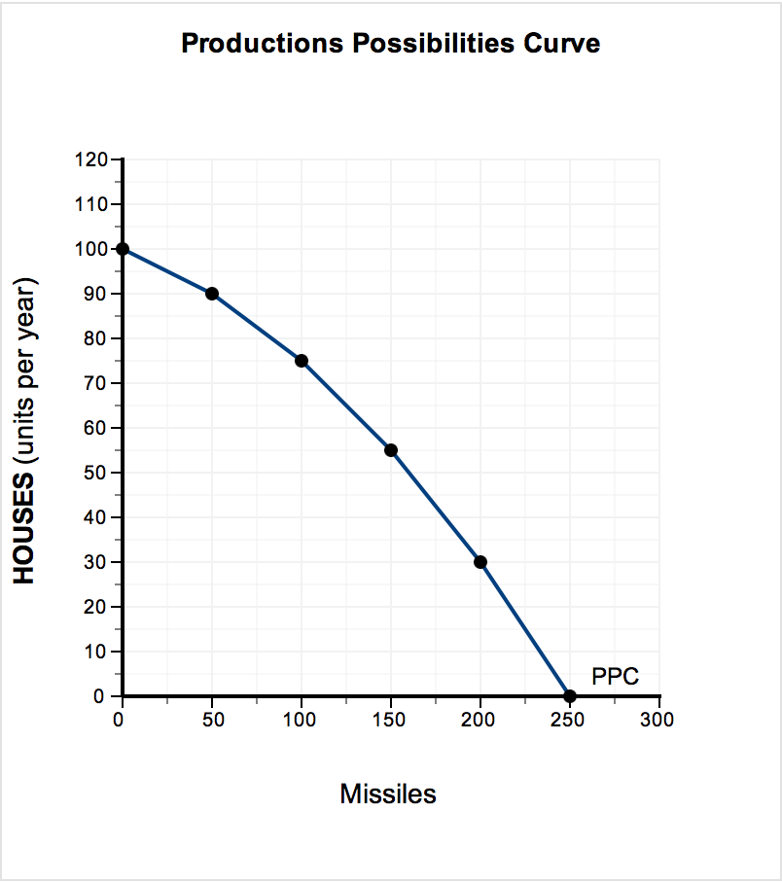

(a) 10 houses

(b) 15 houses

**Explanation:**

(a) The opportunity cost of increasing the production of missiles is the loss of production of houses. For example, increasing missile production from 50 to 100 results in a loss of 15 houses (= 90 – 75), increasing missile production from 100 to 150 results in a loss of 20 houses (= 75 – 55), and so on.

(b) A production possibilities curve describes the various combinations of final goods and services that could be produced in a given time period with available resources and technology. Point A, for example, is an output combination of 0 missiles and 100 houses, plotted on the vertical axis (0,100). Point F, on the other hand, is 250 missiles and 0 houses, plotted on the horizontal axis (250,0).

**LO 01-02**

**Topic: Three Basic Economic Questions**

**AACSB: Analytic**

**Blooms: Level 3 Apply**

1. Assume that it takes four hours of labor time to paint a room and two hours to sand a floor. If all 24 hours were spent painting, (a) How many rooms could be painted by one worker? (b) If a decision were made to sand two floors, how many painted rooms would have to be given up? (c) Illustrate with a production possibilities curve. **(LO 1-1)**

***Answers:***

(a) 6 room(s) painted

(b) 1 room(s) painted

(c) 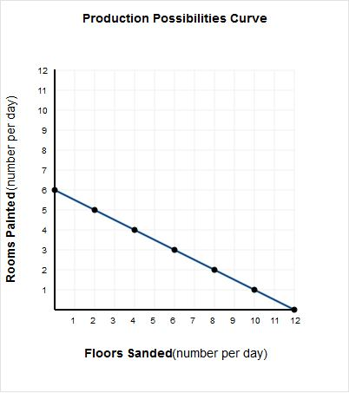

**Explanation:**

(a) If a worker spends 24 hours painting rooms and he or she can paint one room in four hours, then this worker can paint 6 rooms (= 24 hours/4 hours per room).

(b) Because it takes two hours to sand one floor, it would take a worker four hours to sand two floors. Therefore, a worker must give up painting one room, which also takes four hours to complete.

(c) The various production possibilities are plotted with "Rooms Painted" on the vertical axis and "Floors Sanded" on the horizontal axis. Thus, if a worker spends all of his or her time painting rooms, 6 rooms can be painted (0, 6). On the other hand, if a worker spends all of his or her time sanding floors, 12 floors can be sanded (12, 0). The alternative production possibilities points in between those two extremes are (2, 5), (4, 4), (6, 3), (8, 2), and (10, 1).

**LO 01-01**

**Topic: The Central Problem of Scarcity**

**Topic: Three Basic Economic Questions**

**AACSB: Analytic**

**Blooms: Level 4 Analyze**

1. Assume that it takes four hours of labor time to paint a room and two hours to sand a floor. If two workers each spend 24 hours painting, (a) How many rooms could be painted by both workers? (b) If a decision were made to only sand floors, how many floors could be sanded? (c) Illustrate with a production possibilities curve. **(LO 1-1)**

***Answers:***

(a) 12 rooms

(b) 24 floors

(c)

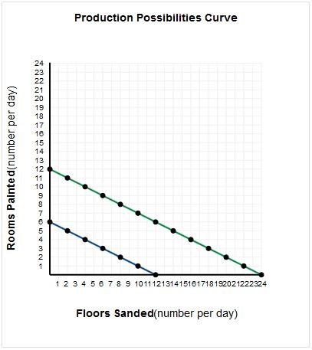

**Explanation:**

(a) If two workers each spend 24 hours painting rooms and they can paint one room in 4 hours, then these workers can paint 12 rooms [= (24 hours × 2 workers)/(4 hours per room)].

(b) If two workers each spend 24 hours sanding floors and they can sand one floor in 2 hours, then these workers can sand 24 floors [= (24 hours × 2 workers)/(2 hours per floor)].

(c) The various production possibilities are plotted with "Rooms Painted" on the vertical axis and "Floors Sanded" on the horizontal axis. Since there are two workers, the production possibilities have doubled. If both workers spend all of their time painting, 12 rooms can be painted (0, 12). On the other hand, if both workers spend all of their time sanding, 24 floors can be sanded (24, 0). Some of the alternative production possibilities points in between those two extremes are (4, 10), (8, 8), (12, 6), (16, 4), and (20, 2).

**LO 01-02**

**Topic: The Central Problem of Scarcity**

**Topic: Three Basic Economic Questions**

**AACSB: Analytic**

**Blooms: Level 4 Analyze**

1. North Korea has a population of 25 million people, of whom 1.1 million are in the military. South Korea has a military of 650,000 out of a population of 49 million. What percentage of the population is in the military in (a) North Korea? (b) South Korea? **(LO 1-2)**

**Answer:**

1. 4.40%
2. 1.33%

**Explanation:**

(a) In North Korea, 4.40% of the population is in the military. Percentage of population in the military = (military/population) × 100 = (1.1 million/25 million) × 100 = 4.40%.

(b) In South Korea, 1.33% of the population is in the military. Percentage of population in the military = (military/population) × 100 = (0.650 million/49 million) × 100 = 1.33%.

**LO 01-02**

**Topic: The Central Problem of Scarcity**

**AACSB: Analytic**

**Blooms: Level 3 Apply**

1. On The table below describes the production possibilities confronting an economy. Using that information: (a) Calculate the opportunity costs of building hospitals. (b) Draw the production possibilities curve. (c) Why can't more of both outputs be produced?  (d) Which point on the curve is the most desired one? **(LO 1-3)**

|  |  |  |  |
| --- | --- | --- | --- |
| **Potential Output** **Combinations** | | **Homeless** **Shelters** | **Hospitals** |
|  | A | 12 | 0 |
|  | B | 10 | 1 |
|  | C | 7 | 2 |
|  | D | 4 | 3 |
|  | E | 0 | 4 |

**Answer:**

(a)

|  |  |  |  |
| --- | --- | --- | --- |
| **Potential Output** **Combinations** | **Homeless** **Shelters** | **Hospitals** | **Opportunity Cost of Building One More Hospital** |
| A | 12 | 0 |  |
| B | 10 | 1 | 2 Homeless Shelters |
| C | 7 | 2 | 3 Homeless Shelters |
| D | 4 | 3 | 3 Homeless Shelters |
| E | 0 | 4 | 4 Homeless Shelters |

(b)

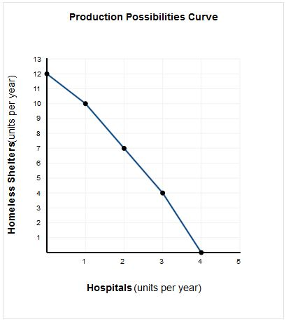

(c)Our resources are limited and are therefore not capable of producing everything we want.

(d) It depends on the value judgements of society.

**Explanation:**

(a) Calculating Opportunity Costs. Opportunity cost is the most desired goods and services that are forgone in order to obtain something else. In this economy, the opportunity cost of building more hospitals is giving up building homeless shelters.

     •  The opportunity cost of producing the first hospital reduces the production of homeless shelters from 12 to 10, or 2 homeless shelters.

     •  The opportunity cost of producing the second hospital reduces the production of homeless shelters from 10 to 7, or 3 homeless shelters.

     •  The opportunity cost of producing the third hospital reduces the production of homeless shelters from 7 to 4, or 3 homeless shelters.

     •  The opportunity cost of producing the fourth hospital reduces the production of homeless shelters from 4 to 0, or 4 homeless shelters.

(b) Graphing the Production Possibilities Curve: A production possibilities curve describes the various combinations of final goods or services that could be produced in a given time period with available resources and technology. For example, one combination of output is 12 homeless shelters and 0 hospitals, a second combination of output is 10 homeless shelters and 1 hospital, and so on.

(c) Because all resources are scarce and therefore limited, we are not capable of producing more of both products. Although we might want more of both (or more of everything perhaps), we are not capable of producing everything that we want.

(d) This answer depends on the value judgments of a society. The most desired point will vary based upon the particular wants and needs of that particular society.

**LO 01-03**

**Topic: Three Basic Economic Questions**

**AACSB: Analytic**

**Blooms: Level 2 Understand**

1. In 2014 the dollar value of total output was roughly $40 billion in North Korea and $1,600 billion in South Korea. South Korea devotes 2.7 percent of its output to defense and North Korea devotes 14.8 percent of its output to defense. **(LO 1-3)**
2. Compute how much North Korea spends on its military
3. Which nation spends more, in absolute dollars?

**Answers:**

(a) $5.92 billion

(b) South Korea

**Explanation:**

(a) North Korea spends approximately $5.92 billion on its military. $5.92 billion = ($40 billion)(14.8%) = ($40 billion)(0.148).

(b) South Korea spends approximately $43.2 billion on its military. South Korea spends a great deal more in absolute dollars than North Korea. $43.2 billion = ($1,600 billion)(2.7%) = ($1,600 billion)(0.027).

**LO 01-03**

**Topic: Three Basic Economic Questions**

**AACSB: Analytic**

**Blooms: Level 5 Evaluate**

1. According to the News Wire “Opportunity Cost” on page 11, what is the opportunity cost of North Korea’s rocket program in terms of corn for North Korea’s 25 million people? **(LO 1-4)**

**Answer:** 4.6 million tons of corn

**Explanation:**

According to the article, the $1.3 billion spent on the rocket launches is equivalent to acquiring 4.6 million tons of corn.

**LO 01-04**

**Topic: Three Basic Economic Questions**

**AACSB: Analytic**

**Blooms: Level 2 Understand**

1. **POLICY PERSPECTIVES** In Figure 1.6,

(a) If as much health care as possible is provided, how many other goods will be provided?

(b) What is the opportunity cost of increasing health care from Point E to Point D? **(LO 1-5)**

**Answers:**

(a) 0 (zero) units of other goods

(b) 200 units of other goods.

**Explanation:**

(a) If a society uses all of its resources to produce health care there are no resources remaining to produce other goods.

(b) When health care production increases from point E to point D (from 0 to 1,000 units of health care), the production of other goods decreases from 4,000 to 3,800. This 200-unit decrease in the production of other goods is the opportunity cost of increasing production of health care from 0 to 1,000 units.

**LO 01-05**

**Topic: Undesirable Choices**

**AACSB: Analytic**

**Blooms: Level 3 Apply**

1. **POLICY PERSPECTIVES** Suppose the following data reflect the production possibilities for providing health care and education:

Units per Year

Health Care        400    370     330     270     190     100      0

Education              0      20       40      50       60      70      80

(a) Graph the production possibilities curve.

(b) If maximum health care is provided, how much education will be provided?

(c) What is the opportunity cost of increasing health care from 270 to 330 units? **(LO 1-5)**

***Answers:***

**(a)** 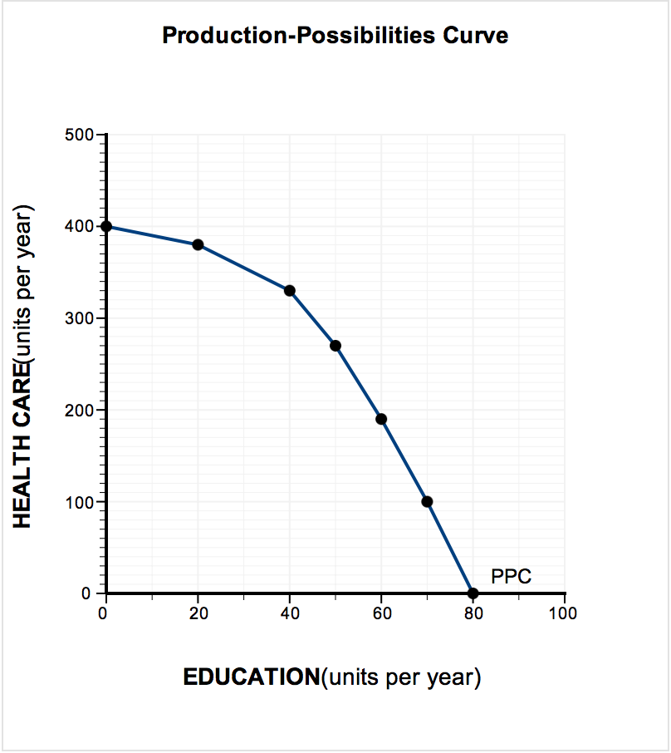

**(b) 0 units of education**

**(c) 10 units of education**

***Explanation:***

(a) A production possibilities curve describes the various combinations of final goods or services that could be produced in a given time period with available resources and technology. For example, one combination of outputs is 400 units of health care and 0 units of education, a second combination of outputs is 370 units of health care and 20 units of education, and so on.

(b) If all resources are used to produce health care, there will be no resources available to produce education.

(c) Increasing health care from 190 units to 270 units results in an opportunity cost of 10 units of education (= 60 units of education – 50 units of education).

**LO 01-05**

**Topic: Undesirable Choices**

**AACSB: Analytic**

**Blooms: Level 4 Analyze**